**FPT ACADEMY INTERNATIONAL**



## FPT – APTECH COMPUTER EDUCATION

Juice Shop

|  |  |  |  |
| --- | --- | --- | --- |
| **Center Name** | | FPT – Aptech – HCM2  Address: 590 Cach Mang Thang Tam, District 3, Ho Chi Minh City | |
| **Instructor** |  | Ms. Le Mong Thuy |  |
| **Class** |  | 2303.M03 |  |
| **Group** |  | 4 |  |
| **Group members** | | **Name** | **Student ID** |
|  |  | Nguyen Minh Trung | Student1462824 |
|  |  | Dao Minh Phi | Student1462836 |
|  |  | Luu Quoc Hoamg | Student1462823 |
| **Duration** | Start date | 19th Jun 2023 |  |
| End date | 24th July 2023 |  |

**This is to certify that**

**Mr.:**

Nguyen Minh Trung

Luu Quoc Hoang

Dao Minh Phi

**has successfully designed & developed**

eProject: Juice Shop

**Submitted by:**

Nguyen Minh Trung

**Date of issue:**

**Authorized Signature:**

**TABLE OF CONTENTS**

****FPT – APTECH COMPUTER EDUCATION 1****

****TABLE OF CONTENTS**** ****2****

****ACKNOWLEGMENT**** ****3****

****SYNOSIS**** ****3****

****PROBLEM DEFINITION**** ****3****

****CUSTOMER'S REQUIREMENTS SPECIFICATIONS (CRS) 4****

****Business/Project Objective**** ****4****

****Hardware/ Software Requirements**** ****5****

****SCOPE OF THE WORK (IN BRIEF) 6****

****Architecture and design of the system 7****

****Diagram of the website 8****

****TASK SHEET REVIEW 1 9****

****SITE MAP 10****

****MOCK OF THE WEBSITE 1********1****

***1. Homepage 1******1***

***2. Product 1******2***

***3. Blog 1******3***

***4. About Us 1******4***

***5. Contact US 1******5***

***6. Service 1******6***

***7. Sign In/ Sign Up 1******7***

****TASK SHEET REVIEW 2 18****

WEBSITE DESCRIPTION ****1********9****

RESPONSIVE****28****

[****JAVASCRIPT DESCRIPTION****](#Javascript) ****30****

****TASK SHEET REVIEW 3**** ****47****

# ACKNOWLEGMENT

# On behalf of the team members, I would like to thank everyone who helped my team complete this project perfectly. In addition, on behalf of the team, I would like to thank the team members for their active participation and contributions to this project, motivating team members to achieve their goals.

# SYNOSIS

# The goal of eProject was that we needed to create a website that presented users with a nutritious drink that was rich in nutrients. "Juice Mix & Smoothie 480 - Dien Bien Phu" is an example of a store that offers beverage products along with other beauty drinks. Because it is a newly established restaurant, we still meet the three elements of delicious, nutritious, and cheap. The main goal of this website is to promote more consumers to know the name of the shop as well as expand the business model. In addition, the product also has discounts and promotions for customers. The experience and product evaluation will be the top priority of the shop to help the shop improve further.

# PROBLEM DEFINITION

The website was created based on the following requirements.

1) Home page must be created using Sections with appropriate icons

2) The website will display a menu containing options for a brief introduction to the different products available, the location of the store, and any other information if required.

3) Information should be categorized by different product types such as if User just wants to see 'Juice' then he clicks on Links/buttons/menu and he will see other types of "Juice" together.

4) When the user selects a product type, a list of products of that product type will be displayed.

5) A brief summary of individual product features will be displayed on the Site along with the product, but detailed Features must be stored in individual Word documents as desired by the User view can download or watch.

6) The price list must be available for download.

7) There should be a “Contact Us” page that will have the Company Address and mail address which when clicked will call the local mail client from which they can send emails. The Company's address must be displayed using the GeoLocation API (e.g. GoogleMaps).

# SCOPE OF THE WORK (IN BRIEF)

After a long and detailed discussion, our team decided to create a website containing the following websites:

1. **Home page**: There is a search bar to search for products, display information about promotions, best-selling products and introductions.
2. **Products**: Displays all available products based on category (juice Mix Smoothies, Milk juices, Detox beautiful skin). In the above categories, products can be filtered by name and price.
3. **About Us**: Displays information about the company, customer reviews and about us.
4. **Contact us**: Display the company's address, Map and allow customers to request any information they want to "Mix Juice & Smoothies"
5. **Service:** Display of user requirements, product documentation and product price list
6. **Sign In/ Sign Up**: Allows users to register or log in to the website.

# ARCHITECTURE AND DESIGN OF THE SYSTEM

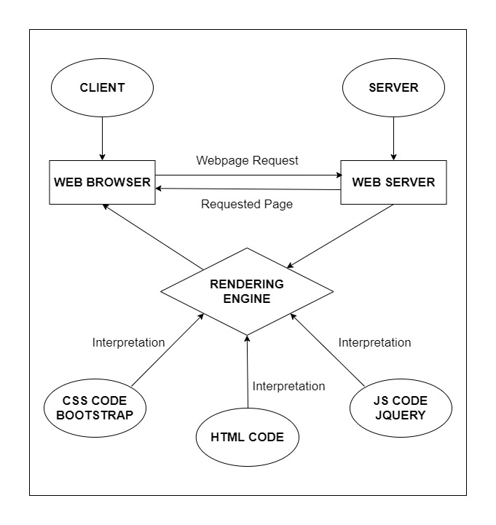

# DIAGRAM OF THE WEBSITE

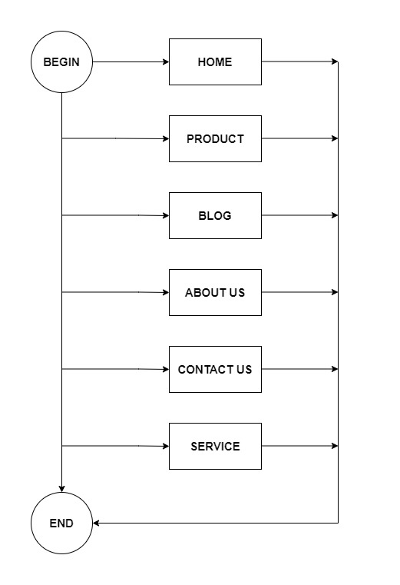



# TASK SHEET REVIEW 1

|  |  |  |  |  |  |  |  |
| --- | --- | --- | --- | --- | --- | --- | --- |
| **Project Ref. No.:**  **eP/Advertisement Portal Management**  **System/01** | | **Project Title:** | **Activity Plan Prepared By:** | **Date of Preparation of Activity Plan:** | | | |
| **Sr.**  **No.** | **Task** | **Actual**  **Start**  **Date** | **Actual Days** | **Team**  **Mate Names** | **Status** |
| 1 | Problem Statement | Juice Shop | Trung | 19-Jun-23 | 1 | Trung | Completed |
| 2 | Analysis of Mixed Juice & Smoothies requirements about the website | 19-Jun-23 | 1 | Trung | Completed |
| 3 | The scope of the work (in brief) | 19-Jun-23 | 1 | Phi | Completed |
| 4 | Architecture and design of the system | 19-Jun-23 | 1 | Phi | Completed |
| 5 | Diagram of the website | 19-Jun-23 | 1 | Hoang | Completed |
| 6 | Task Sheet | 19-Jun-23 | 1 | Hoang | Completed |

|  |  |
| --- | --- |
| **Date:** | |
| Signature of Instructor:  **Ms. Le Mong Thuy** | Signature of Team Leader:  **Nguyen Minh Trung** |

# SITE MAP

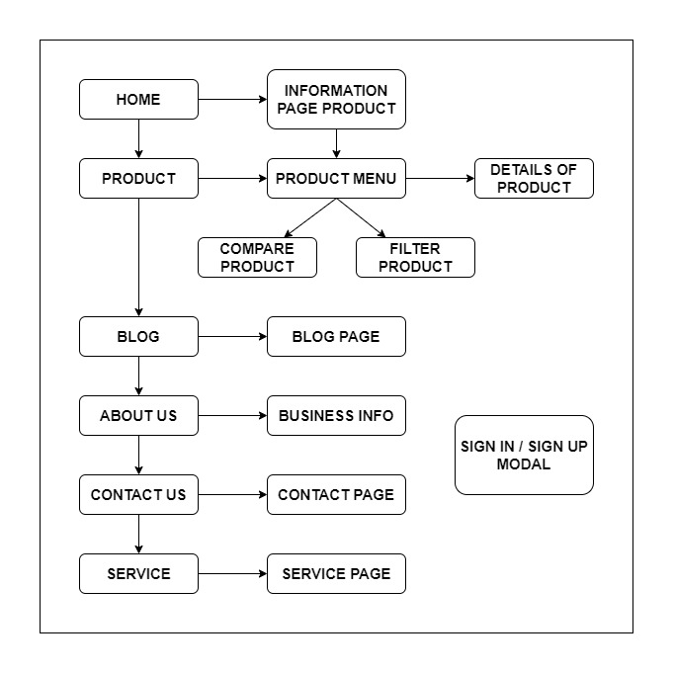

# MOCK OF THE WEB SITE

1. **Homepage**

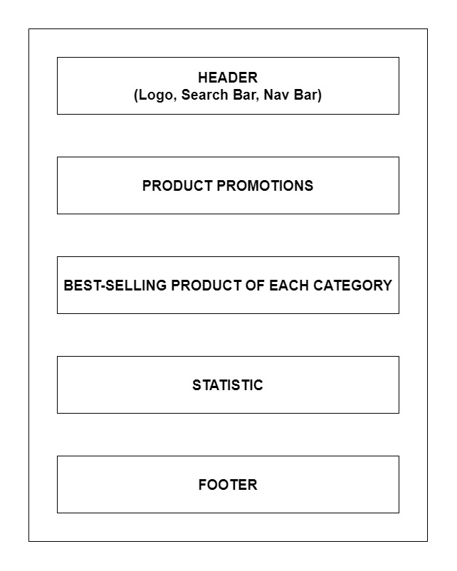

1. **Product**

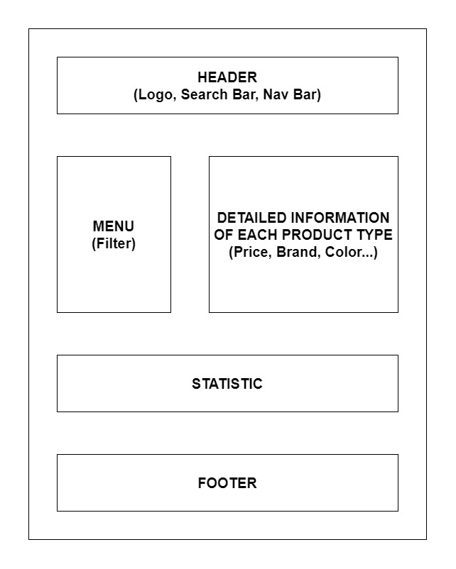

1. **Blog**

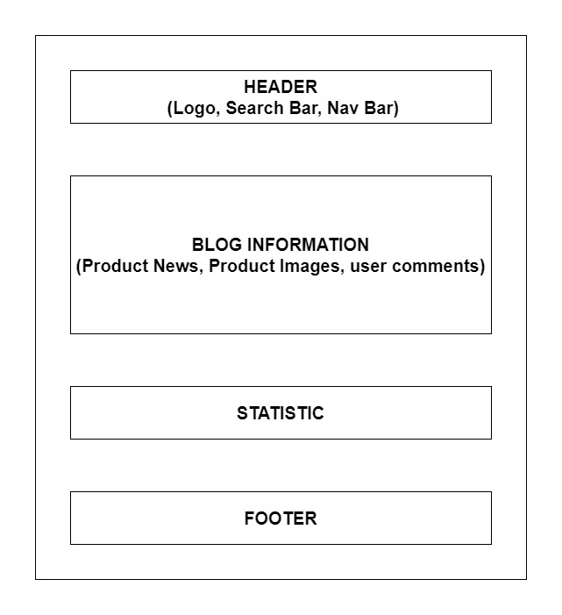

1. **About Us**

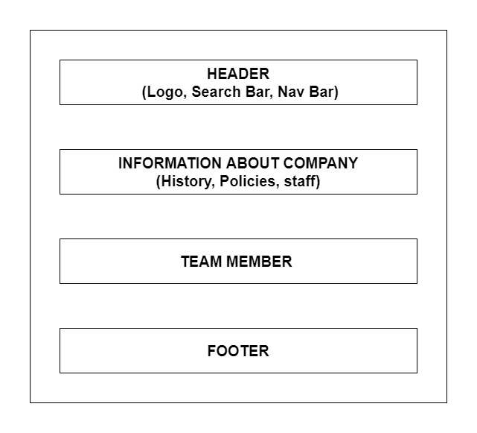

1. **Contact Us**

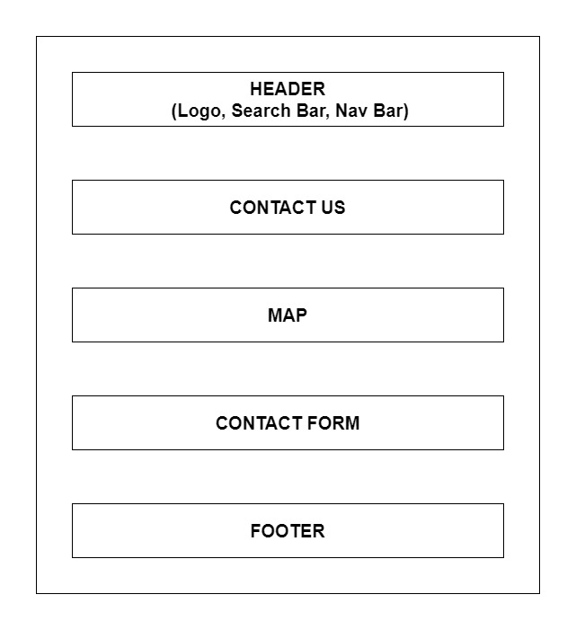

1. **Service**

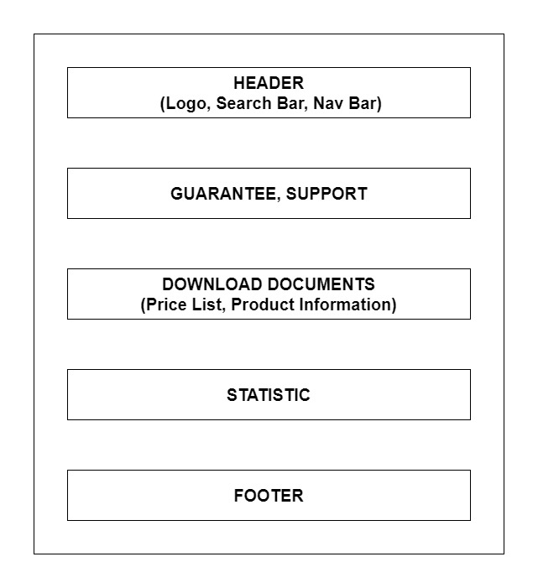

1. **Sign In/ Sign Up**

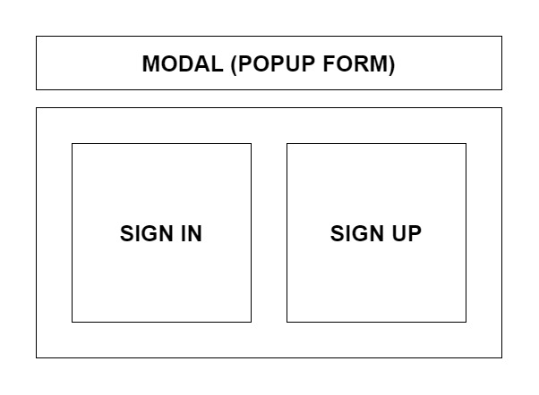

# TASK SHEET REVIEW 2

|  |  |  |  |  |  |  |  |
| --- | --- | --- | --- | --- | --- | --- | --- |
| **Project Ref. No.:**  **eP/Advertisement Portal Management**  **System/01** | | **Project Title:** | **Activity Plan Prepared By:** | **Date of Preparation of Activity Plan:** | | | |
| **Sr.**  **No.** | **Task** | **Actual**  **Start**  **Date** | **Actual Days** | **Team**  **Mate Names** | **Status** |
| 1 | Site Map | Juice Shop | Trung | 19-Jun23 | 2 | Trung | Completed |
| 2 | Mock of the website | 19-Jun-23 | 2 | Phi | Completed |
| 3 | Task sheet | 19-Jun-23 | 2 | Hoang | Completed |

|  |  |
| --- | --- |
| **Date:** | |
| Signature of Instructor:  **Ms. Le Mong Thuy** | Signature of Team Leader:  **Nguyen Minh Trung** |

# 

# TASK SHEET REVIEW 3

|  |  |  |  |  |  |  |  |
| --- | --- | --- | --- | --- | --- | --- | --- |
| **Project Ref. No.:**  **eP/Advertisement Portal Management**  **System/01** | | **Project Title:** | **Activity Plan Prepared By:** | **Date of Preparation of Activity Plan:** | | | |
| **Sr.**  **No.** | **Task** | **Actual**  **Start**  **Date** | **Actual Days** | **Team**  **Mate Names** | **Status** |
| 1 | Home Page | Juice Shop | Trung | 24-July-23 | 1 | Phi | Completed |
| 2 | Product | 24-July-23 | 3 | Phi | Completed |
| 3 | Blog | 24-July-23 | 2 | Phi | Completed |
| 4 | About Us | 24-July-23 | 2 | Phi | Completed |
| 5 | Contact Us | 24-July-23 | 2 | Trung | Completed |
| 6 | Service | 24-July-21 | 2 | Trung | Completed |
| 7 | Sign In/ Sign Up | 24-July-21 | 1 | Trung | Completed |
| 8 | Java Script | 24-July-21 | 2 | Hoang | Completed |
| 9 | Responsive | 24-July-21 | 1 | Hoang | Completed |

|  |  |
| --- | --- |
| **Date:** | |
| Signature of Instructor:  **Ms. Le Mong Thuy** | Signature of Team Leader:  **Nguyen Minh Trung** |

**WEBSITE DESCRIPTION**

**1. Homepage**

a) Description

Home page displays following information:

- Slide show programs, services and product promotions

- Feature product.

- Latest news (Blog).

- Popular Brand.

- Some information about the website.

b) Screen shot

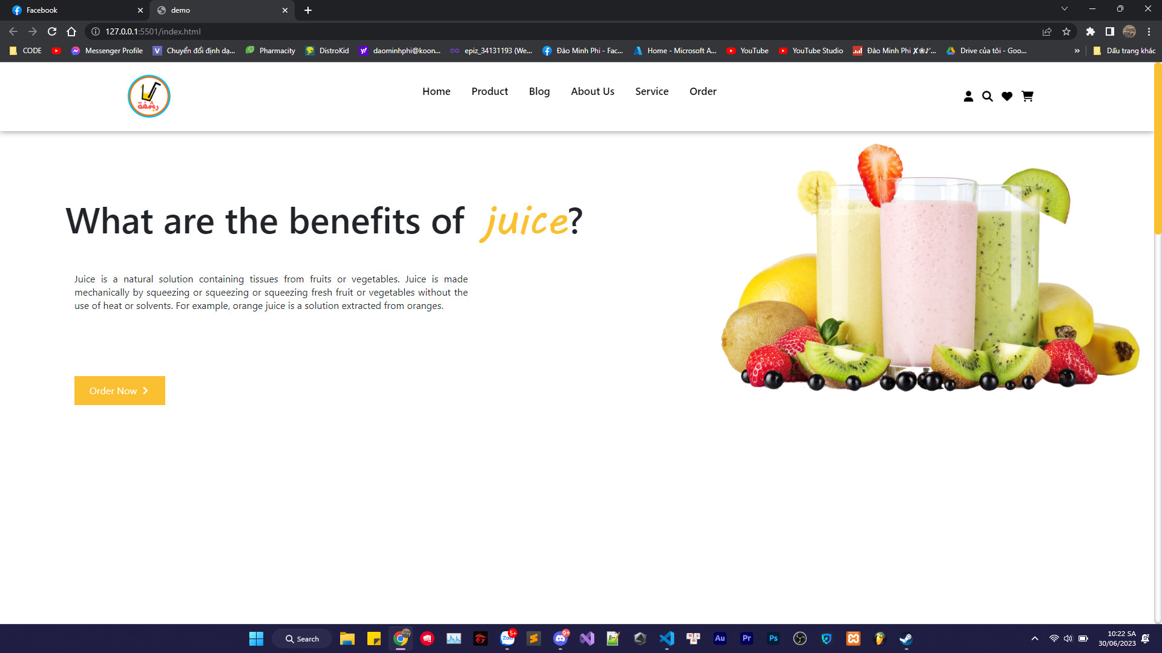

**JAVASCRIPT DESCRIPTION**

